**Project 1**

**Data Source – Kaggle**

<https://www.kaggle.com/zynicide/wine-reviews/downloads/wine-reviews.zip/4>

Wine magazine – ~129K entries

Removed unnecessary columns such as twitter handle, taster name, title, description

Removed blank rows dropna

**Issues/concerns**

We had duplicate entries. The second set of data was revised

The numbers samples per country/state were not consistent

Several scores were listed as “America”

Wine names were spread across columns

Graphs:

Fig1 – Wine Score by State

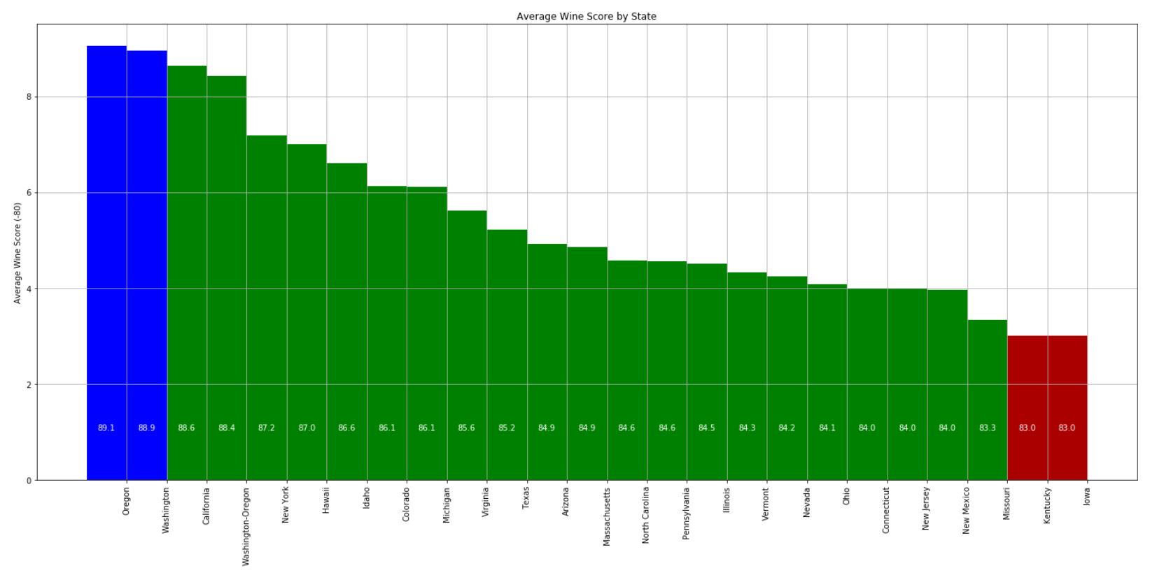Fig2 – Wine Score by Country

